Viranda Games

User Training Guide

This program is designed to store an inventory of products, along with customer details and transaction details for each product purchased. All information will be written to three binary files.

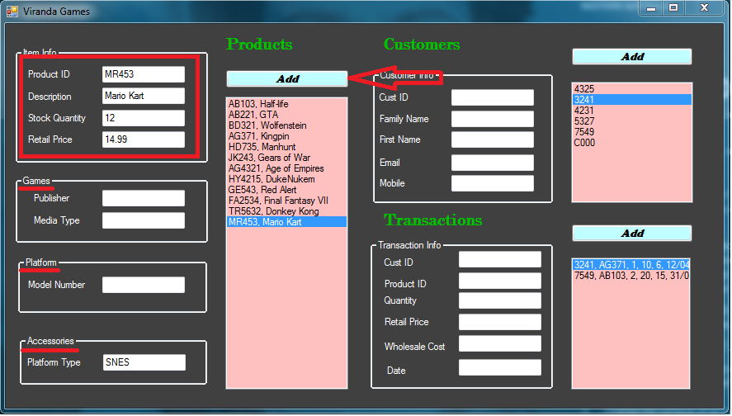To add an item to the products list, the item info group must be entered along with one other group. Then press the add button to add to the inventory list.

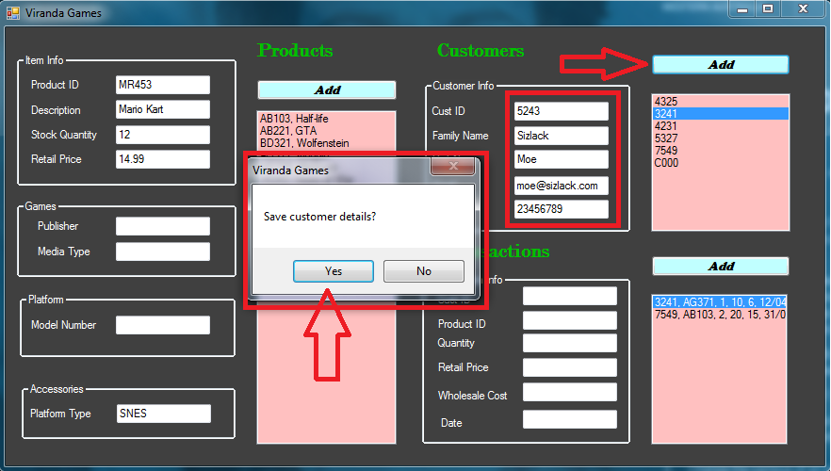To add a customer details, all details must be inputted to the text fields. Then press the add button. You will be prompted to save the details, if you select no, an anonymous default entry will be entered.

To add a new transaction, all fields highlighted in red must be entered. Then press the add button.

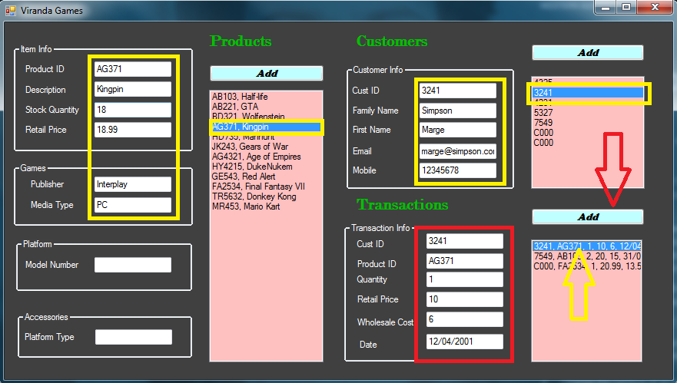

When an item is selected from the list boxes, its information will be displayed in the text fields. If a transaction item is selected the appropriate text fields from customer and product will also be displayed, as highlighted in yellow.

All data will be saved to file upon closing the application.